**Naïve Bayes :**

KNN was just based on neighbourhood concept while Naïve Bayes is based on concepts of probability.

So the first concept of probability is Conditional probability.

P(A|B) is way in which conditional probability is represented , where A and B are random variables.

And to understand it better lets say P(A=a|B=b) which means Random variable A takes a value ‘a’ and random variable B takes value ‘b’.

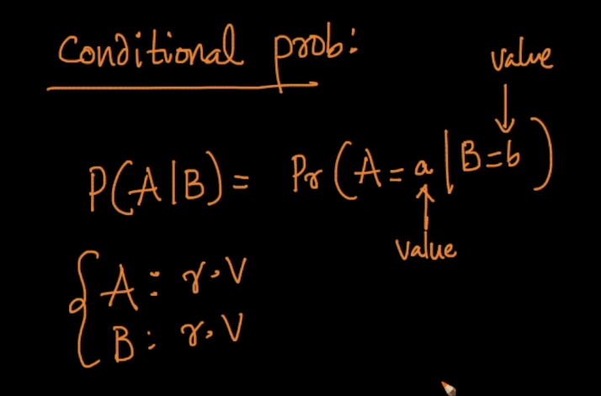

Lets take an example of rolling of two dice .

When we role a dice it can maximum gives 6 outcomes i.e., 1,2,3,4,5,6 and we role another dice it can also give one of six outcome.

So rolling both dice together will give us 6*6 outcomes i.e., 36 outcomes and this possible outcomes are called “**Sample Spaces”**

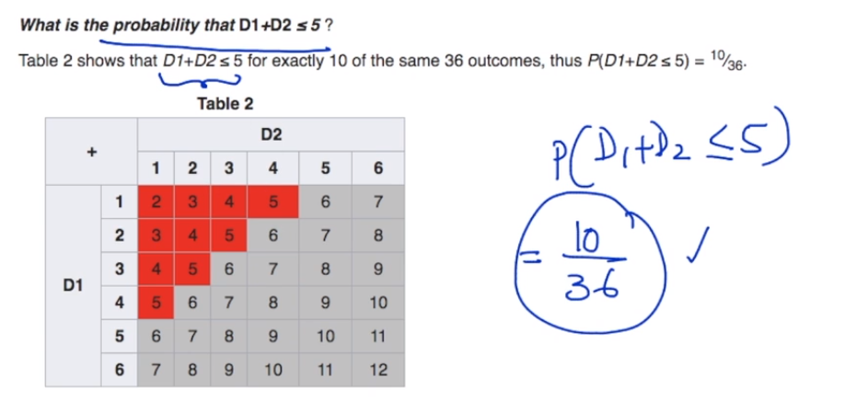

In above image each cross block is sum of two outcomes i.e, D1(outcome of first dice) + D2(Outcome of second dice).

If D1 = 1 and D2= 1 then A11 is = 2(Starting indexing from 1 and not from 0).

So if we ask what is the probability of getting sum of 5 and less so we can easily find that there are only 10 blocks with value 5 and less so probability will be (10/36).

Now lets take first example of conditional probability.

(Note: Remember conditional probability comes into picture when we are given an already occurred scenario and asked probability of another scenario which is dependent on occurred scenario)

So in above box suppose if it given that sum of outcomes is <= 5 and asked a question what is probability of getting D1 = 2 and it can be written in mathematics like P(D1=2|D1+D2<=5)

Symbol ‘|’ in above equation is said to be condition .

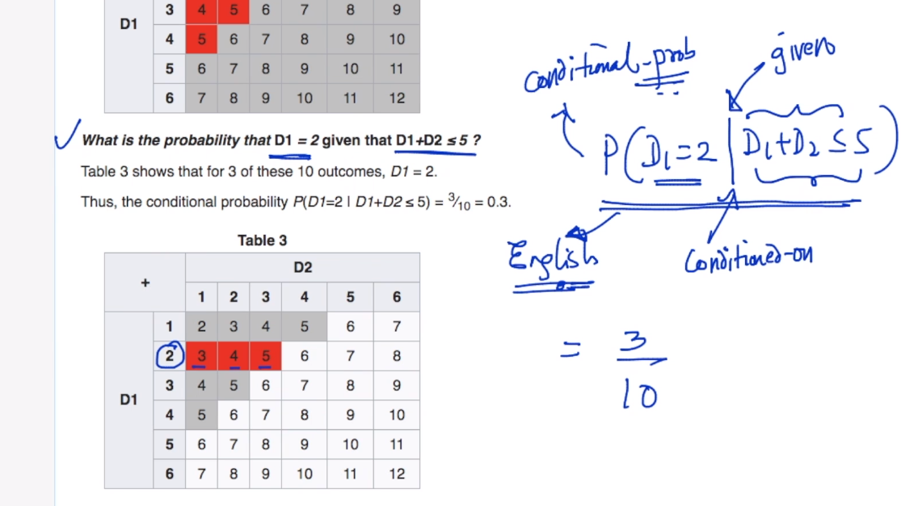

So in above image we can see that when sum is less than or equal to 5 we only have 10 blocks satisfying already occurred condition and asked question is P(D1=2)

So out of 10 outcomes 3 satisfies the condition and so the final answer for P(D1=2 | D1+D2 <=5) = 3/10.

Now lets understand the mathematics behind the conditional probability ,

It says P(A|B) = P(A and B)/P(B) {here and is intersection}

So taking above example P(A) is P(D1 = 2) and P(B) = P(D1+D2 <= 5)

So P(A and B ) = P (D1= 2 and D1+D2<=5) = 3/36 and P(B) = 10/36

3/36/10/36 = 3/10.

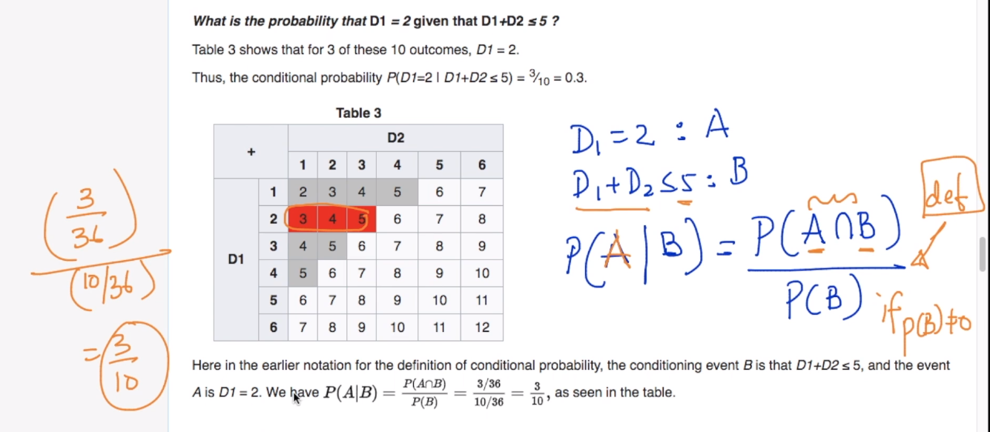

The easy limitation to this is that given P(B) should not be zero otherwise this is not defined.



NOTE: - TO make probability easy always try to read equations in simple English.